CENTRAL UNIVERSITY OF SOUTH BIHAR
Department of Bioinformatics
End-Term Open Book Examination Session: 2020-2022 Semester: 2nd

Programme: M.Sc Bioinformatics Date: 26.07.2021

Course Code: MSBIS2005C04 Course Title: Evolution & Molecular phylogeny
Duration: 2 ½ hours Course Credits: 4
Maximum Marks: 50

Instructions:
- Preferably write your answers on A4 size plain paper (non-ruled) sheets.
- Write your required details on the first page in the same order as specified below:

Name: ………………………………………. Programme:……………………………. Semester: ………………….
Course Title: ………………………………………………… Course Code: .…………………………………………...
Total No. of pages used: ………………………………..

Date: ………………………………………………………………. Signature: ………………………………………………..
- After completing the examination, write page number on the top right corner of each page
in the format: 1/x, 2/x, , x/x where ‘x’ is the total number of pages used. If you have used
total 6 pages then your page numbers will be 1/6, 2/6, 6/6.

- The students have to write the answers on both side of the sheet (A4 size plain paper non ruled sheet.

- The questions asked here are basically designed to assess the interpretation and application of knowledge, comprehension skills, and critical thinking skills rather than only recalling capacity.
- Total twelve short answer questions of five points each are given covering the entire course content.
- Answer any ten questions in total in maximum two and half hours.
- The maximum limit to answer a question is 200 -300 words.
- At the start of the examination all the questions will be released through e-mail and/or WhatsApp.
- The total time limit to attempt the question paper is two and half hours. Along with the two and half hours, extra 30 minutes will be given for IT related activities such as downloading questions, scanning of answer sheets and uploading/emailing them.
- After completing the examination within the stipulated time (two and half hours, scan your answer sheets or click pictures and submit it electronically in one single file (preferably PDF) to the course instructor through e-mail (kris@cub.ac.in) strictly within stipulated time limit for submission (Three hours). Before submitting, rename your file and keep your name and enrolment number as file name.
- Please note that do not use these extra 30 minutes for writing answers. Rather, finish writing as soon as possible within two and half hours and immediately submit your answers in the prescribed way given below. Due to any reason, if a student is unable to submit the answer sheet file within the time limit, the university will not consider this examination and conduct another examination in the conventional mode whenever the conditions return to normal and circumstances permit or the university deems suitable. No other option or reason shall be entertained.
- In case you feel difficulty in submitting the answer sheet file through e-mail, then you are required to submit it to the concerned course instructor through WhatsApp within the stipulated time only and email it later on (within 48 hours) along with the screen shots of WhatsApp submission.
……………………………………………………………………………………………………………….

Question Paper (Answer any 10 questions. 10 * 5 = 50 Marks)

Q1. Does “survival of the fittest “ always applicable in a population? Describe your opinion.

Q2. Describe the phenomenon used by humans in the evolution of desirable characteristics in plants and animals.

Q3. In a fossil sample, the amount of C¹⁴ is 12 gm. What will be the age of fossil assuming that initially, it was 36 gm. and half-life of C¹⁴ is 5700 years.

Q4. Birds and bats both can fly. Are they evolutionarily linked? Explain

Q5. What is gene flow? Describe its effect on the population.

Q6. Does nature play a direct role in mutation? discuss your views

Q7. In a plant species, the ability to grow in copper contaminated soil is determined by the dominant allele. In a field experiment, 64% of seeds were able to germinate in that contaminated soil. Based on the data calculate the frequency of heterozygous seedlings in the population.

Q8. Explain the concept of monophyletic and polyphyletic clad in the phylogenetic tree given below.
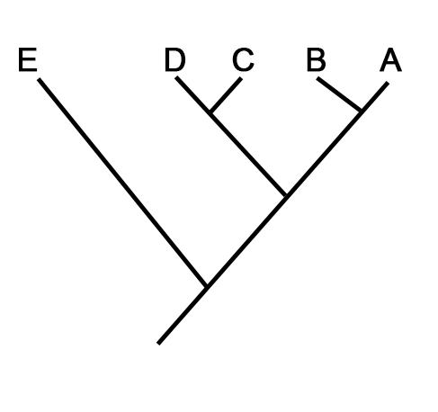

Q9. Describe the significance of relative rate test in molecular phylogeny?

Q10. Using fitch parsimony approach label the sequence of all internal nodes of the tree given below.
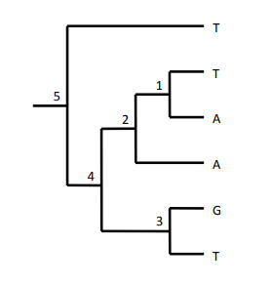

Q11. Using the sequence data given below create pairwise distance matrix and a UPGMA phylogenetic tree.

Sp1 ATGCATGGGTTGA
Sp2 ATCGACCAGGTGA
Sp3 ATGCACCCTGATC
Sp4 GCATGCGGGCACC

Q12. Based on the given sequence data, construct the most Parsimonious tree.

Sp1 GAT
Sp2 CAT
Sp3 GCA
Sp4 CCA

